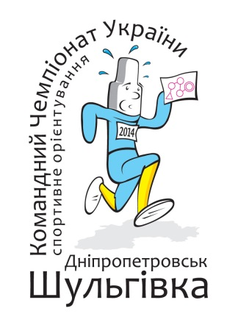
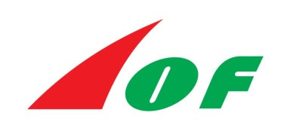
IOF World Ranking Events
(Middle)
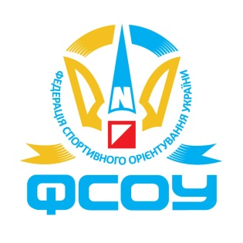
Ukrainian Orienteering Championships 2014
in Middle, Sprint, Sprint Relay, Long and Relay

7-12 May 2014
Dnipropetrovsk Region, Ukraine

BULLETIN 1

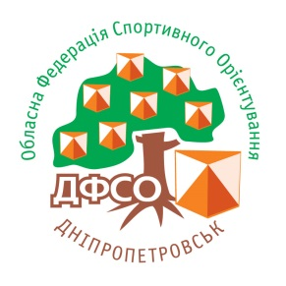

ORGANIZERS Ukrainian Orienteering Federation
Ministry of Youth and Sports of Ukraine
Dnipropetrovsk Regional Orienteering Federation
Dnipropetrovsk Regional Youth and Sport State Department

ORGANIZATION COMMITTEE


Event Director Mykola Filchenko (Dnipropetrovsk)
Chief Secretary Valery Zaerko (Dnipropetrovsk)

Course planners Dmytro Kositsyn (Sprint, Sprint Relay, Middle - WRE)
Vladyslav Laskarzhevsky (Long)
Oleksandr Ievstafyev (Relay) – all Dnipropetrovsk


IOF WRE Adviser

UOF Controller Vitalii Petrov (Kyiv)
UOF Controller Assistant Vasyl Tkachenko (Kyiv)

INFORMATION

Homepage http://orienteering.dp.ua
Contact person (RU) Mykola Filchenko | +380 67 565 7121, +380 99 552 1616 | x239fnm@gmail.com
Contact person (EN) Vladyslav Laskarzhevsky | +375 29 388 2331 | vladyslav.laskarzhevsky@gmail.com

VENUE

The Event Centre PERLYNA Camp, 1 Zelena str., Radyanske village, Poltava region, Ukraine.
Competition Area According to the map (google maps).

EVENT PROGRAMME
7 May 2014,  Wednesday | 10:00-18:00  11:00-17:00  19:00 | Teams arrivals, Event Centre open hours. Registration.  Model Event  Team Officials Meeting (Event Centre)
8 May 2014,  Thursday | 13:00  14:00 | Opening Ceremony (arena)  Start for Middle Distance (WRE)
9 May 2014,  Friday | 09:00  14:00  17:00 | Start for Sprint Distance  Start for Mixed Sprint Relay (4 legs: W+M+M+W)  Team Officials Meeting (arena)
10 May 2014,  Saturday | 10:00  15:00  16:00 | Start for Long Distance  Prize Giving Ceremony (arena)  Team Officials Meeting (arena)
11 May 2014,  Sunday | 10:00  14:00 | Start for Relay (3 legs)  Prize Giving Ceremony (arena)
12 May 2014,  Monday | 9:00-12:00 | Teams Departure
CLASSES AND PARTICIPATION

World Ranking Events Classes
Individual events: MW 21E

Ukrainian Orienteering Championships Classes
Individual events: MW 12, 14, 16, 18, 20, 21E, 21A, 35, 40, 45, 50, 55, 60, 65, 70, 75, 80
Relay: MW 12, 14, 16, 18, 20, 21 & 110, 135, 160, 180 (classes with age limit for 3 relay team members)
Mixed Sprint Relay: MW 12, 14, 16, 18, 20, 21 & 140, 180, 220, 260 (classes with age limit for 4 relay team members)

Competitors from other countries are welcomed to take part in the entire event within the above mentioned classes, however will not be eligible for titles, medals and diplomas in Ukrainian Championships or Ukrainian Cup. Also separate prize giving ceremony for World Ranking Events will be organized where all the participants may compete for the podium.

Start and start lists
An individual interval start will be with a 2 minute start interval.
All entered runners will be divided and distributed into three starting groups.
Individual start times for the races will be:
- early: those, who has NO ranking – points in IOF World Rankings – will be drawn randomly and will be places in the beginning of the start list;
- middle: the start order will be determined strictly by the reverse standing of the IOF World Rankings (for Middle and Long) as published on 30 April 2014;
- late: the best 8 runners as determined by the standing of the IOF World Rankings (for Middle and Long) as published on 30 April 2014 will be drawn randomly and will in the end of the start list.

TERRAIN

The terrain presents a unique combination of sand dunes, marshes and pine forest.

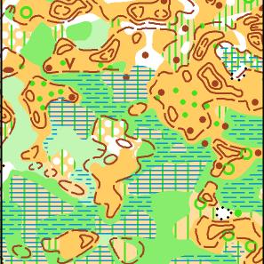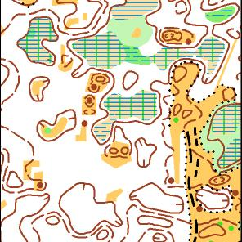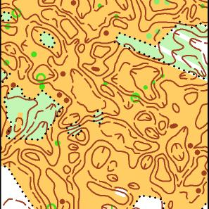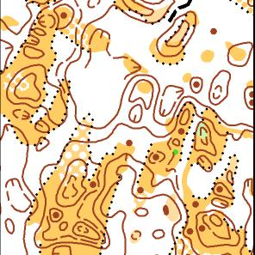

MAPS

Map makers: Oleksandr Mykhailov, Roman Slobodyanuk, Sergiy Usenko, Oleksandr Gavryluk (all – Ukraine).
The maps were prepared in 2011-2014.
The standard ISOM specification is followed in map preparation for long, middle and relay.
The map scale is 1:10 000.
The standard ISSOM specification is followed in map preparation for sprint and sprint relay.
The map scale is 1:5 000.

COURSES

Detailed courses’ length will be published in Bulletin 2. Estimated winner’s time is planned as following:
Middle: 35 min for both MW 21E
Long: 90 min for M21E, 70 min for W21E

PUNCHING SYSTEM

The SportIdent system will be used in all the categories.
The participants without SportIdent may rent one from the organizers with a cost of UAH 20 per day for MW 12-16 classes and UAH 30 per day for all other classes.

REGISTRATION DATES

All entries should be submitted to organizers not later than 1 May 2014 through the online registration form (will be available from 10 April 2014) http://orient.z52.ru/index.php .
REGISTRATION FEES

MW 21E (IOF WRE): 6 Euro per race / 20 Euro for all 5 races.
Entry fees to be paid in cash during registration in Event Centre on 07 May 2014.
UOF members are entitled to pay reduced entry fee according to Ukrainian Orienteering Federation regulations.

ACCOMMODATION

PERLYNA Camp, 1 Zelena str., Radyanske village, Poltava region, Ukraine
The Event Centre location.Distance to arenas: 6-8km.
Offered rooms include all the facilities except kitchen. Prices vary from UAH 90 to UAH 350 per person per night with limited availability. The camp operates a bar-restaurant and offer a meal packages (breakfast, lunch and dinner) for a cost of UAH 70-90 per day.
For details please visit the web-site: http://www.perlina.org.ua/

NEPTUN Camp, Dniprodzerzhynsk, Dnipropetrovsk region, Ukraine
Located within 5 km from Dniprodzerzhynsk. Distance to arenas: 20-25 km. Distance to event center: 30km.
Offered rooms are very basic and do not provide any facilities. The cost is UAH 25 per person per night.
Also accommodation in tents is possible at a cost of UAH 10 per person per night.
WC and water is available at site. Cooking is possible at specially designated areas.

GOLDEN SUNDS Holiday Village, Dniprodzerzhynsk, Dnipropetrovsk region, Ukraine
Located within 5 km from Dniprodzerzhynsk. Distance to arenas: 20-25 km. Distance to event center: 30 km.
Offered rooms include all the facilities except kitchen. Prices vary from UAH 300 to UAH 800 per person per night with limited availability. For details please visit the web-site: http://www.goldensand.com.ua/

TRANSPORT

Arranged transport will be available and include:
- initial transportation form Dniprodzerzhynsk to the accommodation areas upon arrival;
- daily transportation from accommodation areas to event arenas;
- final transportation to Dniprodzerzhynskat departure.

More details will be published in Bulletin 2.

